## Exercise 1.8.5: Table of Favorites

Using an HTML table, make a table that lists your favorite things for each day. Each day of the week will be a column in the table. The rows will be your

* favorite food to eat for breakfast
* favorite activity to do on that day
* favorite person to hang out with on that day
* favorite place to go on that day

The table headers should have the name of each day of the week.

For example, the table could look something like this:

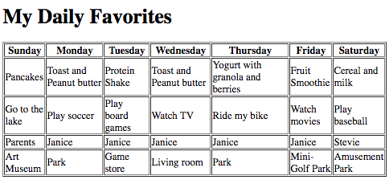

**BONUS CHALLENGE:**

List more than one favorite thing in a table cell (td) by using a list.